

Group 6 Technical Report

Data Modelling for Intelligent Networks and Security

Cutillas Pardines Mario

사마리딘

정세웅
1. Manual of use

In this point, we will cover the setup necessary to replicate the environment of this project. Firstly, the installation of OpenDaylight and Mininet should be as described in the tutorial provided by the subject through i-Campus, so we’ll assume that part as covered. After proper set-up of both Vms, all necessary features should be installed into the ODL controller through the command:
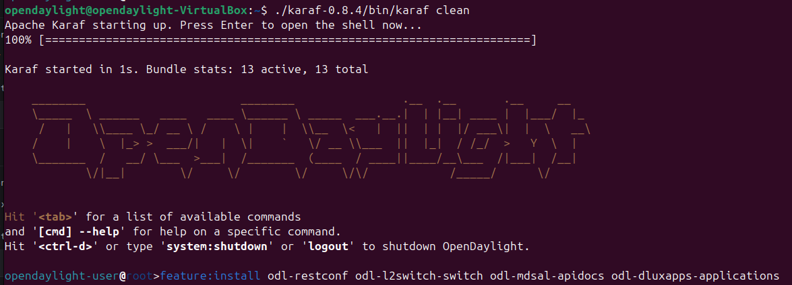
After this setup, through the creation of a simple topology such as:
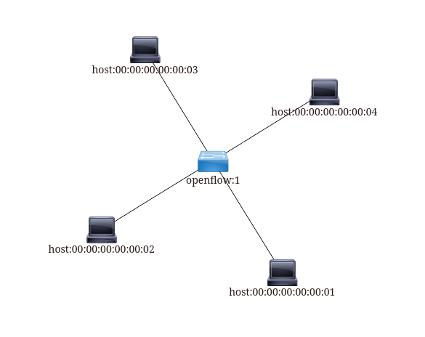
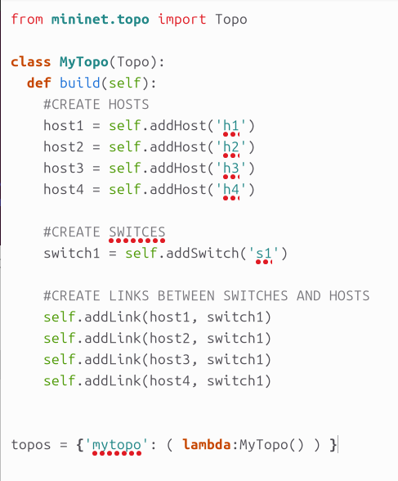
This is merely an example, as the requests sent won’t be actually from within this network but rather a simulation, though the script will push policies to the controller.

Due to the dependencies of some of the libraries used, a virtual environment will be necessary to run the script. This can be accomplished by running the following commands:

The github link is the following: https://github.com/jaehoonpauljeong/KICS2026-Group6.git
It contains the script so the user only has to copy the repository and run.
After this, the system is ready to run the enforcer.py file!

The simulation of the login attempts is done with the following command

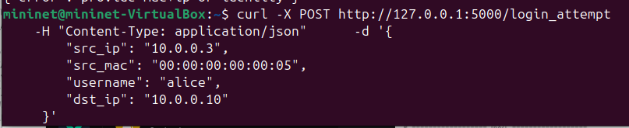
The fields are pretty self-descriptive, and other parameters such as geographical location would be taken from the python libraries.
As it stands, all login attempts deemed unsafe would be redirected to a possible VPN NSF, but as its implementation is beyond the scope of this project, it will simply assume that the login has been successful and save the corresponding data for future logins.

2. Code explanation

Here we will proceed to explain the code used in the script fit the logic of the project.

2.1 Identity Construction
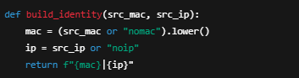

To guarantee that adaptive behavioral profiles remain independent between users, the system constructs a unique identity by combining the MAC and IP address observed during a login attempt. These values are concatenated into a canonical identity string of the form <mac>|<ip>. This ensures strict separation of behavioral learning across devices and prevents profile contamination, where one user’s historical patterns might incorrectly influence another's risk score.
2.2 Database History Recording
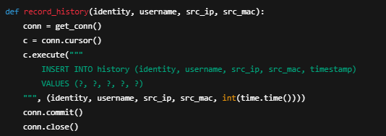
Each login attempt—regardless of outcome—is recorded in a history table. This allows the system to evaluate whether the user’s current behavior is consistent with past sessions. Historical data contributes directly to the “history factor” in the risk model, enabling differentiation between first-time and habitual behavior. By indexing history entries by identity, the model ensures that historical familiarity applies only to the corresponding device-user pair.

2.3 User Profile Storage and Retrieval
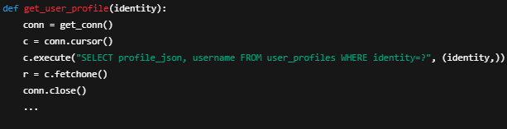

Behavioral features, such as trusted MAC usage frequency, subnet familiarity, time-of-day statistics, and country occurrence, are persisted in a per-identity profile. When no prior profile exists, a new one is created automatically. This persistent structure enables adaptive learning: users benefit from lower risk assessments as their behavior becomes increasingly predictable.

2.4 MAC Address Learning
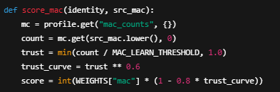

The system learns which MAC addresses are normal for a given identity by counting successful authentications. A nonlinear trust curve converts recurrence into a decreasing risk contribution. This gradual trust accumulation avoids binary decisions and ensures that MAC-based risk decreases smoothly as the system gains confidence in the device.

2.5 Subnet and Location Familiarity
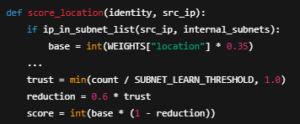

The model evaluates whether the source address belongs to an internal, VPN, or public subnet. Internal subnets are considered inherently safer, while public subnets incur higher risk. Furthermore, the system learns which subnet category a user typically employs, gradually reducing risk for repeated familiarity. This prevents over-penalization of legitimate recurring remote logins.

2.6 Time-of-Day Behavioral Modeling

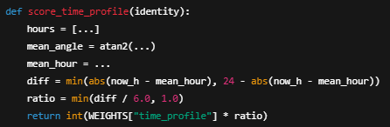

Temporal behavior is modeled by transforming historical login hours into a circular statistical space, computing a mean usage angle, and comparing it to the current login time. Larger deviations represent abnormal access patterns and therefore higher risk. This method provides a continuous, mathematically grounded temporal anomaly detector rather than using fixed time windows.

2.7 Geolocation Familiarity
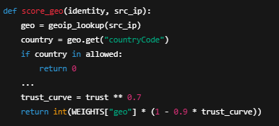

The system performs a country-level geolocation lookup and maintains a list of the most frequently observed countries per identity. Countries that appear consistently become “trusted locations” with significantly lower risk. Unexpected geographic origins incur higher scores but decay gradually through adaptive learning. In private network environments, geolocation remains constant, but the mechanism functions normally in external deployments.

2.8 Adaptive Profile Update After Successful Login

Upon successful authentication, the user’s profile is updated with new observations: MAC usage, subnet category, country of origin, and time of access. These updates directly influence future risk assessments, enabling a self-improving model that becomes more accurate and user-specific over time. This feedback loop ensures that legitimate users experience lower friction while anomalous behavior remains scrutinized.

2.9 Risk Score Computation
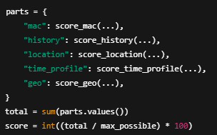

Risk assessment is performed by aggregating individual factor scores into a normalized 0–100 scale. Each factor contributes proportionally according to its assigned weight, allowing the system to express risk as a unified metric. This modular scoring framework supports easy rebalancing and the integration of additional factors in future work.

2.10 Risk-Based Access Decisions and Enforcement
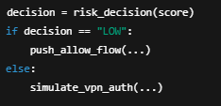

Final access control decisions are based on thresholded interpretations of the aggregate risk score. Low-risk logins are automatically allowed through temporary SDN flow rules. High-risk logins trigger additional authentication steps, represented here by a simulated VPN challenge. This adaptive enforcement approach balances security and usability, granting seamless access when behavior is normal while applying stricter controls under suspicion.

3. Closing statement

We want to clarify again the purpose and use of this script. It is prepared to be used in a SDN network with an already working VPN-like NSF that would ensure safety for the first few logins. It was made in a simulated environment with the intent of recreating as accurately as possible the flow of a real network. We stand by the idea and think it would be worth implementing in a lot of cases where extra authentication steps are needed very frequently, and hope it can be of use for some.

